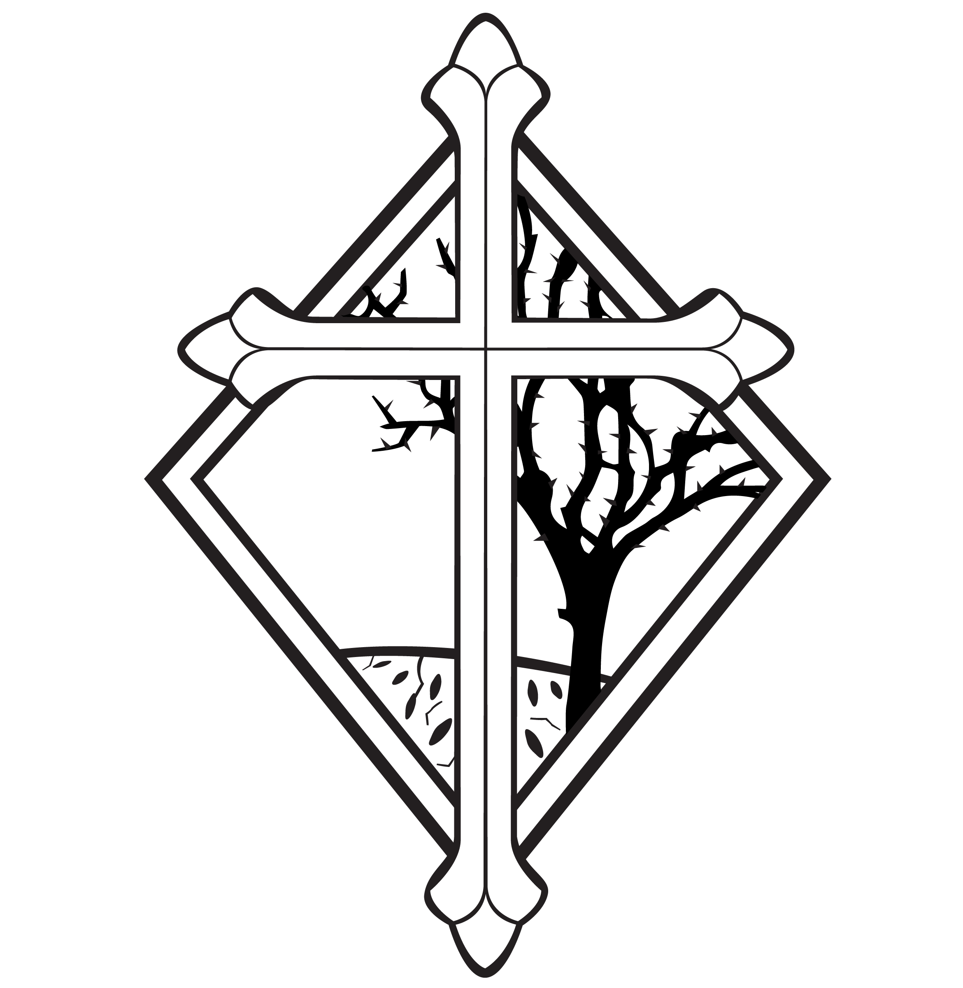

3rd Sunday after Pentecost
CHRIST LUTHERAN CHURCH | Lodi, California
June 18, 2023

WELCOME TO WORSHIP
Welcome to Christ Lutheran Church. We pray that your soul will be strengthened by the good news about God’s grace, love, and forgiveness given to us. If you would like to learn more about our church, please speak with our pastor or one of our members after the service.
- Bathrooms are located in the fellowship hall. A changing table is located in the women’s bathroom.
WORSHIP THEME
Jesus warns us against those who bring false teaching into his church. Our Savior wants us to build our faith and lives on the only solid foundation that can be found: his perfect righteousness, his innocent death, and his glorious resurrection. His teaching astonishes those who listen to him because they can hear that he teaches with authority: not only the authority to guide our life and preaching, but the authority to declare us righteous and give us eternal life.
The Service of the Word and Sacrament
The high and holy worship of God is faith in Jesus Christ. Such faith is created and sustained by God’s service to us (the German, “Gottesdienst,” “God/Divine Service). In the Divine Service, the Lord comes to us in His Word and Sacrament to bless and enliven us with His gifts. The Service is not something we do for God, but His service to us received in faith. The liturgy is God’s work. He gives, we receive.
HYMN Speak O Savior, I am Listening | CW 283
INVOCATION
M: The grace of our Lord ✙ Jesus Christ and the love of God and the fellowship of the Holy Spirit be with you.
C: And also with you.

CONFESSION
From God’s Word we know that wherever God puts His name, there He is to bless. In the Old Testament the temple was the place where God graciously caused His name to be present (1 Kings 8:27-30).
God has put His name —Father, Son, and Holy Spirit—on us in Holy Baptism. The Divine Service begins with the Invocation, the words spoken over us at our baptisms. Every Divine Service is for the hallowing of the Lord’s name, which the Small Catechism reminds us is done “when the Word of God is taught in its truth and purity, and we, as the children of God, also lead holy lives according to it” (Matthew 28:18-20).
M: God invites us to come into his presence and worship him with humble and penitent hearts. Therefore, let us acknowledge our sinfulness and ask him to forgive us.
C: Holy and merciful Father, I confess that I am by nature sinful, and that I have disobeyed you in my thoughts, words, and actions. I have done what is evil and failed to do what is good. For this I deserve your punishment both now and in eternity. But I am truly sorry for my sins, and trusting in my Savior Jesus Christ, I pray: Lord, have mercy on me, a sinner.

absolution
M: God, our heavenly Father, has been merciful to us and has given his only Son to be the atoning sacrifice for our sins. Therefore, as a called servant of Christ and by his authority, I forgive you all your sins in the name of the Father and of the Son ✙ and of the Holy Spirit.
C: Amen
LORD, HAVE MERCY - Kyrie
M: For all that we need in life and for the wisdom to use all your gifts with gratitude and joy, hear our prayer, O Lord.
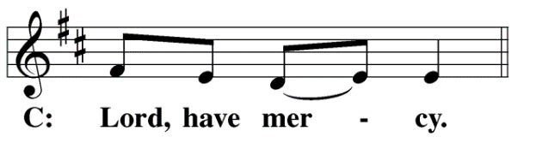
M: For the steadfast assurance that nothing can separate us from your love and for the courage to stand firm against the assaults of Satan and every evil, hear our prayer, O Christ.
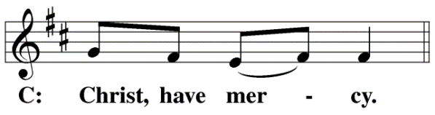

M: For the well-being of your holy Church in all the world and for those who offer here their worship and praise, hear our prayer, O Lord.
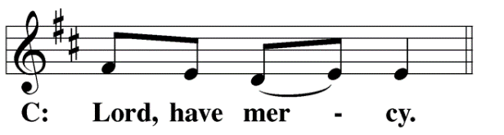
M: Merciful God, maker and preserver of life, uphold us by your power and keep us in your tender care:
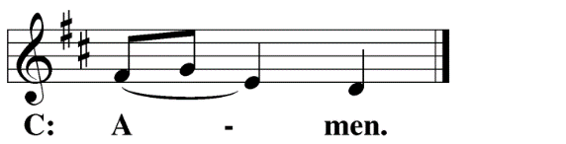
M: The works of the Lord are great and glorious; his name is worthy of praise.
O LORD, OUR LORD
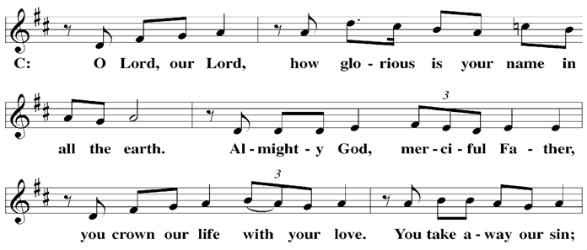

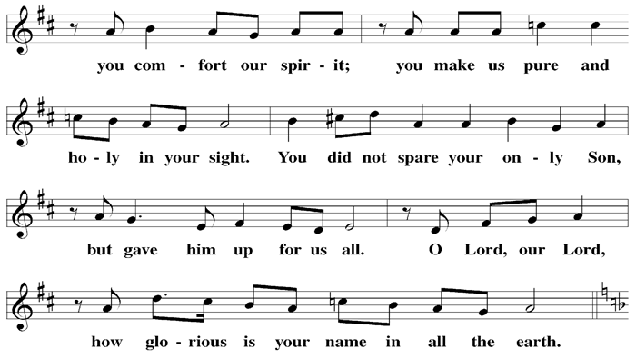

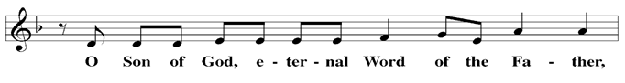

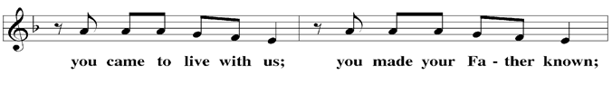

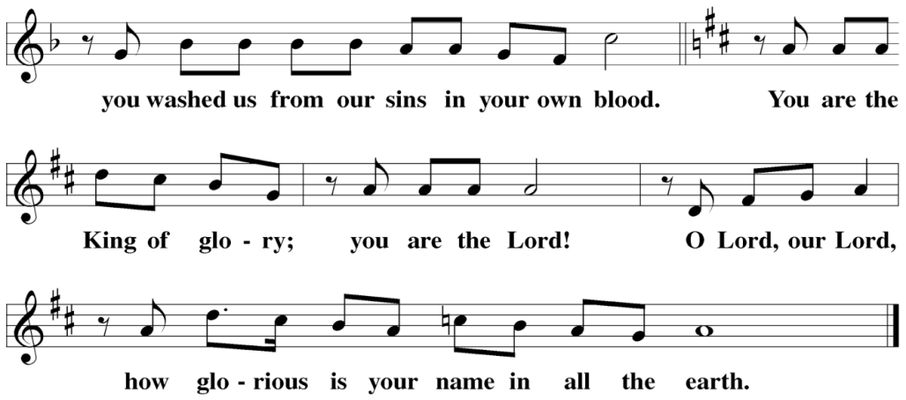

The Service of the Word
Having just received absolution for their sins, believers now gather around the Word of God to find encouragement and peace for their lives on earth.
PRAYER OF THE DAY
M: Let us pray.
O God, you rule over all things in wisdom and kindness. Take away everything that may be harmful and give us whatever is good; through your Son, Jesus Christ our Lord, who lives and reigns with you and the Holy Spirit, one God, now and forever.
C: Amen
FIRST LESSON Deuteronomy 11:18–21,26–28
The letter of the law led the Israelites—and even many Jewish people today—to write these very words of God and place them in phylacteries hung on their bodies. But the spirit of the law tells us a greater truth: by the power of the Word, Jesus gives us faith and eternal life.
18 Fix these words of mine in your hearts and minds; tie them as symbols on your hands and bind them on your foreheads. 19 Teach them to your children, talking about them when you sit at home and when you walk along the road, when you lie down and when you get up. 20 Write them on the doorframes of your houses and on your gates, 21 so that your days and the days of your children may be many in the land the Lord swore to give your ancestors, as many as the days that the heavens are above the earth.
26 See, I am setting before you today a blessing and a curse— 27 the blessing if you obey the commands of the Lord your God that I am giving you today; 28 the curse if you disobey the commands of the Lord your God and turn from the way that I command you today by following other gods, which you have not known.
PSALM Psalm 78, pg. 95

SECOND LESSON Romans 3:21–25a,27,28
Outward obedience leaves much of the Law of works undone. All have sinned. But when we see our need and throw ourselves on God’s mercy, trusting in his grace, we find that Christ has fulfilled the law for us.
21 But now apart from the law the righteousness of God has been made known, to which the Law and the Prophets testify. 22 This righteousness is given through faith in Jesus Christ to all who believe. There is no difference between Jew and Gentile, 23 for all have sinned and fall short of the glory of God, 24 and all are justified freely by his grace through the redemption that came by Christ Jesus. 25 God presented Christ as a sacrifice of atonement, through the shedding of his blood—to be received by faith. He did this to demonstrate his righteousness, because in his forbearance he had left the sins committed beforehand unpunished— 26 he did it to demonstrate his righteousness at the present time, so as to be just and the one who justifies those who have faith in Jesus.
27 Where, then, is boasting? It is excluded. Because of what law? The law that requires works? No, because of the law that requires faith. 28 For we maintain that a person is justified by faith apart from the works of the law.
VERSE OF THE DAY Psalm 119:105
Alleluia. Your word is a lamp to my feet and a light for my path. Alleluia.
THE GOSPEL Matthew 7:15–29
Build on the Rock! No other foundation will allow you to stand except the life, work, death, and resurrection of Jesus.
15 “Watch out for false prophets. They come to you in sheep’s clothing, but inwardly they are ferocious wolves. 16 By their fruit you will recognize them. Do people pick grapes from thornbushes, or figs from thistles? 17 Likewise, every good tree bears good fruit, but a bad tree bears bad fruit. 18 A good tree cannot bear bad fruit, and a bad tree cannot bear good fruit. 19 Every tree that does not bear good fruit is cut down and thrown into the fire. 20 Thus, by their fruit you will recognize them.
21 “Not everyone who says to me, ‘Lord, Lord,’ will enter the kingdom of heaven, but only the one who does the will of my Father who is in heaven. 22 Many will say to me on that day, ‘Lord, Lord, did we not prophesy in your name and in your name drive out demons and in your name perform many miracles?’ 23 Then I will tell them plainly, ‘I never knew you. Away from me, you evildoers!’
24 “Therefore everyone who hears these words of mine and puts them into practice is like a wise man who built his house on the rock. 25 The rain came down, the streams rose, and the winds blew and beat against that house; yet it did not fall, because it had its foundation on the rock. 26 But everyone who hears these words of mine and does not put them into practice is like a foolish man who built his house on sand. 27 The rain came down, the streams rose, and the winds blew and beat against that house, and it fell with a great crash.”
28 When Jesus had finished saying these things, the crowds were amazed at his teaching, 29 because he taught as one who had authority, and not as their teachers of the law.
M: This is the Gospel of the Lord.
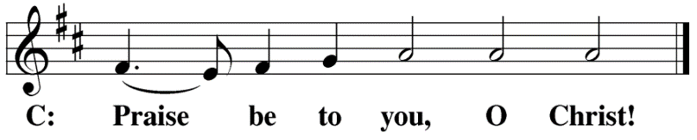
HYMN OF THE DAY My Hope is Built on Nothing Less| CW 382
SERMON Matthew 7
NICENE CREED
Having heard the Word of God, we confess our faith in His name. The creed is our saying back to God what He has first said to us. In the Creed we acclaim the truth of the triune God and His work of salvation accomplished for us in His incarnate Son, Jesus Christ.
We believe in one God, Dt. 6:4
The Nicene Creed is the great Confession of the Christian faith professed by all Christians. The Creed originated at the First Council of Nicaea (c. AD. 325)
the Father, the Almighty, 2 Cor. 6:18
maker of heaven and earth, Is. 51:13
of all that is, seen and unseen. Col. 1:16
We believe in one Lord, Jesus Christ, 1 Cor 8:6
the only Son of God, Jn. 3:16
eternally begotten of the Father, Heb. 1:2,5
God from God, Light from Light, true God from true God, Jn. 1
begotten, not made, of one being with the Father. Jn. 10:30
Through him all things were made. Jn. 1:3

For us and for our salvation, 1 Th. 5:9
he came down from heaven, Jn. 6:38
was incarnate of the Holy Spirit and the virgin Mary, Lk. 1:35
and became fully human. Gal. 4:4
For our sake he was crucified under Pontius Pilate. Mk. 15:15
The Creed itself was crafted as a confession of Scripture in opposition to the Arian heresy, which denied that the Lord Jesus and the Holy Spirit are God.

He suffered death and was buried. 1 Cor. 15:3-4a
On the third day he rose again in accordance
with the Scriptures. 1 Cor. 15:4b
He ascended into heaven Ac. 2:33-34
and is seated at the right hand of the Father. Heb. 1:13
He will come again in glory Mt. 25:31
to judge the living and the dead, 2 Tim. 4:1
and his kingdom will have no end. Lk. 1:33
We believe in the Holy Spirit, the Lord, the giver of life, Job 33:4
who proceeds from the Father and the Son, Jn. 15:26
who in unity with the Father and the Son Jn. 4:24
is worshiped and glorified,
who has spoken through the prophets. 2 Pet. 1:25
We believe in one holy Christian Mt. 16:18; Eph. 2:19-20
and apostolic Church.
We acknowledge one baptism for the forgiveness of sins. Eph. 4:5; Ac. 2:38
We look for the resurrection of the dead 1 Cor. 15:21-22
and the life of the world to come. Amen. Rev. 22

OFFERING
In response to God’s love and forgiveness, we give back a portion of what he has given us. The members of Christ Lutheran Church have joined to proclaim the gospel to this community. These offerings support that work. While our guests are welcome to participate, they should not feel obligated to do so.

PRAYER OF THE CHURCH
M: O Lord, our God, you are wise and powerful, good and gracious. Your mercies are new every morning. Each day you open your hand and provide for the needs of your children on earth.
C: We praise you for every grace and blessing.
M: Strengthen your Church in all the world. Let your comforting message of salvation in Christ Jesus be proclaimed to troubled souls everywhere.
C: Use our ministries and offerings to extend your healing and your hope.
M: We bring you our requests for the various structures of our society: bless our national, state, and local government.
C: Grant us civil servants who are worthy of honor and respect; and bless them as they serve us.
M: Grant prosperity to our businesses and industries according to your will and purpose. Make employers fair toward their workers and employees joy and pride in what they accomplish.
C: Help us find satisfaction in all work well done.
M: Invigorate our schools. Give success to efforts that help students learn how to be informed and responsible citizens and may they use the gifts you give for the benefit of those around them. Arouse curious minds to discover the wonders of your created order.
C: Give us teachers and students who pursue excellence.
M: Strengthen the family. Give fathers and mothers the desire to be good parents. Give children wisdom to see their parents as gifts from you.
C: Lead us to love one another as you have loved us.
Special prayers and intercessions may follow.
M: Hear us, Lord, as we bring you our private petitions.
Silent prayer.
M: Gracious Father, we pray boldly as Jesus taught, with the confidence that you will hear and with the faith that you will answer for our good.

LORD’S PRAYER Matthew 6:9-13; Luke 11:2-4
C: Our Father, who art in heaven,
hallowed be thy name,
thy kingdom come,
thy will be done on earth as it is in heaven.
Give us this day our daily bread;
and forgive us our trespasses,
as we forgive those
who trespass against us;
and lead us not into temptation,
but deliver us from evil.
For thine is the kingdom
and the power and the glory
forever and ever. Amen.

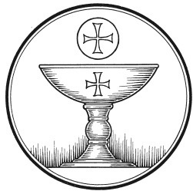
The Service of the Sacrament
This greeting marks a new service, so to speak. These ancient introductory words & phrases help to highlight, celebrate and bring attention to the Sacrament.
M: The Lord be with you.
C: And also with you.
M: Lift up your hearts.
C: We lift them up to the Lord.
M: Let us give thanks to the Lord our God.
C: It is right to give him thanks and praise.
M: Praise to the God and Father of our Lord Jesus Christ! In love he has blessed us with every spiritual blessing. He sends the Holy Spirit to testify that we are his children and to strengthen us when we are weak. Now have come the salvation and the power and the kingdom of our God and the authority of his Christ. To him who sits on the throne and to the Lamb be praise and thanks and honor and glory for ever and ever:

HOLY, HOLY, HOLY – Sanctus
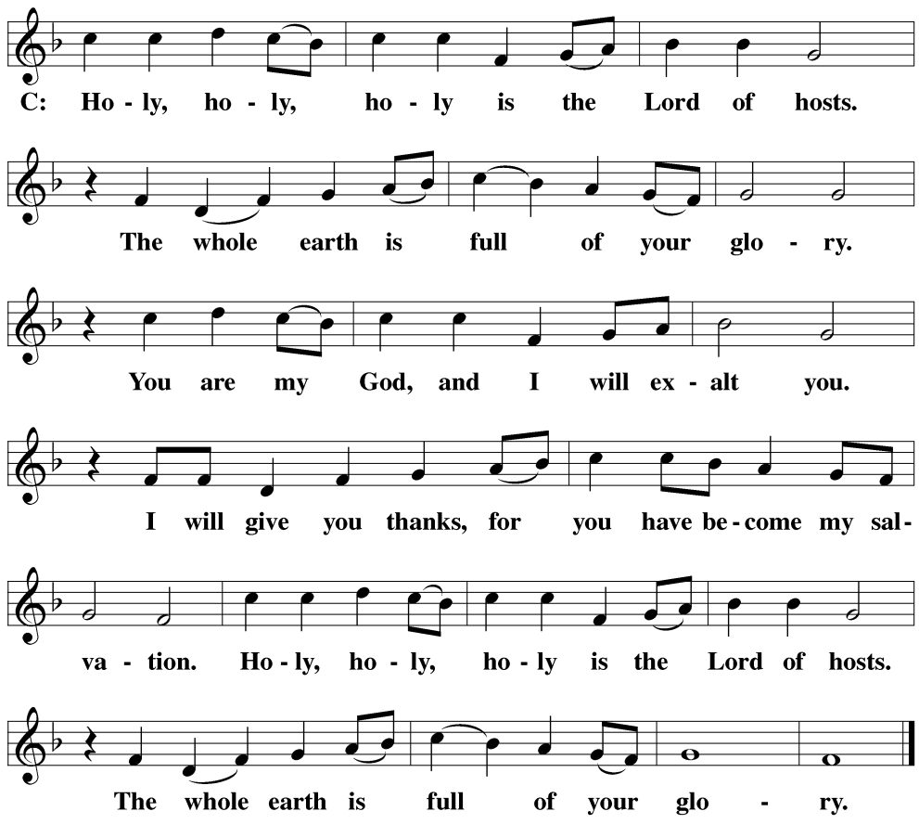
WORDS OF INSTITUTION Matthew 26, Mark 14, Luke 22
M: Our Lord Jesus Christ, on the night he was betrayed, took bread; and when he had given thanks, he broke it and gave it to his disciples, saying: “Take and eat. This is my ✙ body, which is given for you. Do this in remembrance of me.”
The Words of institution both proclaim the words of Jesus to the congregation and sets apart the bread and wine for the Lord’s Supper.
Then he took the cup, gave thanks, and gave it to them, saying, “Drink from it all of you; this is my ✙ blood of the new covenant, which is poured out for you for the forgiveness of sins. Do this, whenever you drink it, in remembrance of me.”
PEACE OF THE LORD – Pax Domini John 20:19
M: The peace of the Lord be with you always.
C: Amen

O CHRIST, LAMB OF GOD – Agnus Dei John 1:29
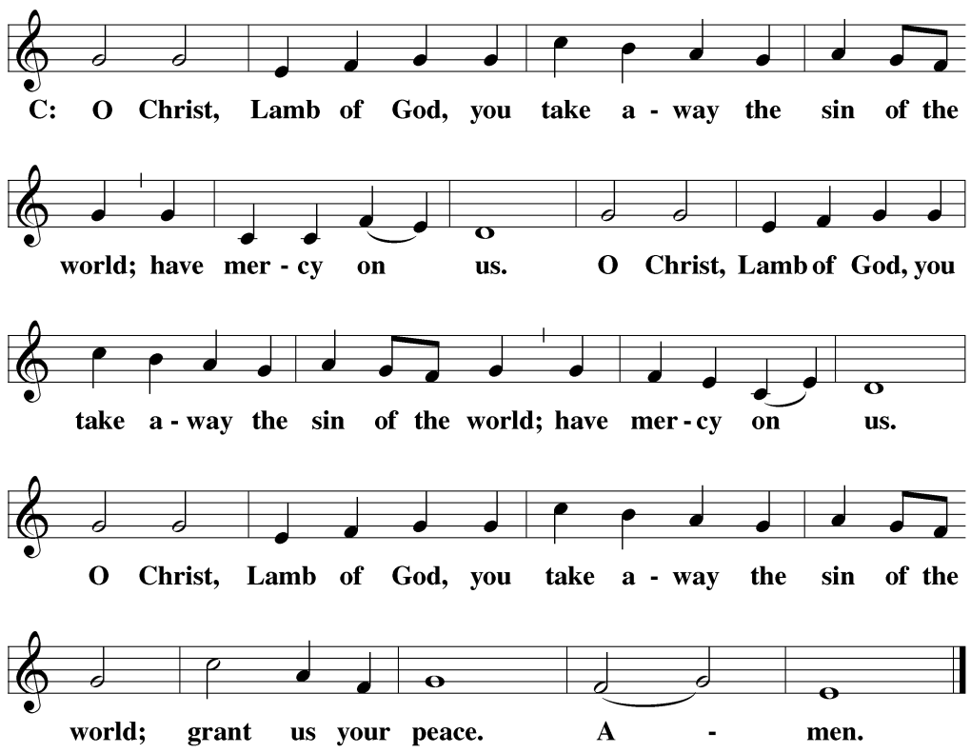
DISTRIBUTION
Those who will be receiving Holy Communion today may wish to read Personal Preparation for Holy Communion, found on page 156 in the front section of the hymnal. This page helps us put into practice what the Bible encourages: “Everyone ought to examine themselves before they eat of the bread and drink from the cup.” (1 Corinthians 11:28)
Christ Lutheran Church confesses and practices the Biblical teaching of a Closed Communion. We ask that only members of the Wisconsin Synod [WELS] or the Evangelical Lutheran Synod [ELS] join us at the Lord’s Table. If you have questions concerning our communion practice, or would like to inquire about how you, too, can commune with us, please speak with the Pastor following the service.

THANK THE LORD
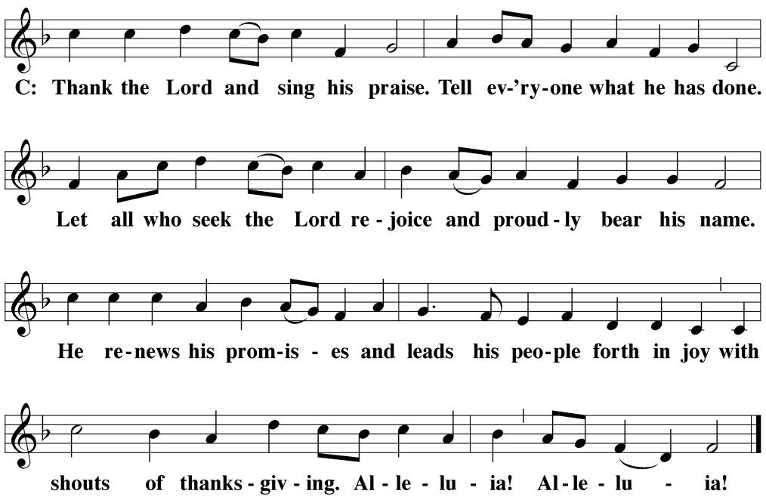
M: Hear the prayer of your people, O Lord, that the lips which have praised you here may glorify you in the world, that the eyes which have seen the coming of your Son may long for his coming again, and that all who have received in his true body and blood the pledge of your forgiveness may be restored to live a new and holy life, through Jesus Christ, our Lord, who lives and reigns with you and the Holy Spirit, one God, now and forever.
C: Amen.

THE BLESSING
M: Brothers and sisters, go in peace. Live in harmony with one another. Serve the Lord with gladness.
The Lord bless you and keep you.
The Lord make his face shine on you and be gracious to you.
The Lord look on you with favor and ✙ give you peace.
C: Amen.
CLOSING HYMN How Firm a Foundation | CW 416

COPYRIGHT INFORMATION
Content requiring a copyright license is reproduced under OneLicense.net #A-718312. All rights reserved. The Common Service: Texts revised from The Lutheran Hymnal, 1941. Music revised by James Engel. Scripture Quotations: From the Holy Bible, New International Version (NIV 1984), © 1973, 1978, 1984 by Biblica, Inc.

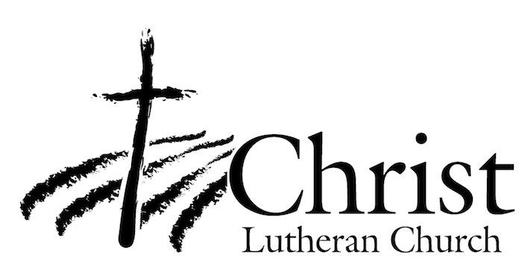
13009 N. Elderberry Ct.
Lodi, CA 95242
www.christlodi.org
209-368-6250
Pastor Joshua Hanson
WELCOME TO CHRIST EV. LUTHERAN CHURCH!
We preach a message of forgiveness, hope and peace
through the death and resurrection of Jesus Christ.
Families and individuals of all ages will find opportunities
both to grow and to serve.
Our mission statement:
Look what Christ is doing!
He binds us together in fellowship
He gathers us in for worship
He builds us up for service
He sends us out with the gospel

“Now you are the body of Christ,
and each one of you is a part of it.”
(1 Corinthians 12:27)

